# CPT_Logo_Manual.jpg Creating Sites and Employing Features

**Lab Time**: 60 minutes

**Lab Overview:** In this lab you will learn to plan and conduct site creation. You will also explore the Features that ship with SharePoint and practice activating some of them to witness their effects on a site.

## Exercise 1: Planning and Creating New Sites

In this exercise you will practice planning and creating a new site.

1. Log into your Wingtip Team Site site collection using the account **Rob Walters** which in the **Owners** group of the top level site.
2. Using Internet Explorer, browse to the URL of the SharePoint site collection you were provided to use when working on the hands on labs in this course.
3. When prompted to login, enter [[AD-DOMAIN]]\rob in the **User Name** field and click **OK**. Use the password specified in the *Hands-On Lab Overview* document provided in the student manual.
4. The Wingtip team has requested an additional subsite in the Wingtip Team Site site collection. Specifically, they want to track and collaborate on the scheduling of the manufacturing assembly line. The new subsite will offer the same Features and services as existing sites and use the same authentication provider as well as administrators. All permission assignments currently in force on the Manufacturing site in the site collection are appropriate for the newly proposed scheduling subsite as well. For ease of access the team wants to keep the new subsite in the Wingtip Team Site. Plan the new site below:

|  |  |  |
| --- | --- | --- |
| **Section** | **Property** | **Value** |
|  | Site Collection |  |
|  | Parent Site |  |
|  | Site Template |  |
| Title and Description | Title |  |
|  | Description |  |
| Web Site Address | Site URL |  |
| Permissions | Inheritance |  |
| Navigation Inheritance | Inheritance |  |

1. During change control meetings about your plan from the last step, the team has agreed to a specific site design. Create the new site as follows:
2. Navigate to the Wingtip Team Site site collection's **Manufacturing** site by clicking the site's link in the Top Navigation Bar.
3. Click the **All Site Content** link in the Quick Launch Bar then click the **Create** link in the toolbar:

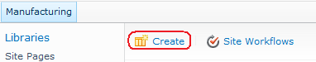

1. In the resulting **Create** dialog scroll down to the bottom of the template listing and click on the **Team Site** button to select the template. In the right pane of the window, the Team Site template name and description should appear with the opportunity to create a new site with all default values by simply entering a title and URL value. Read the site description then click the **More Options** button to customize the site creation values.

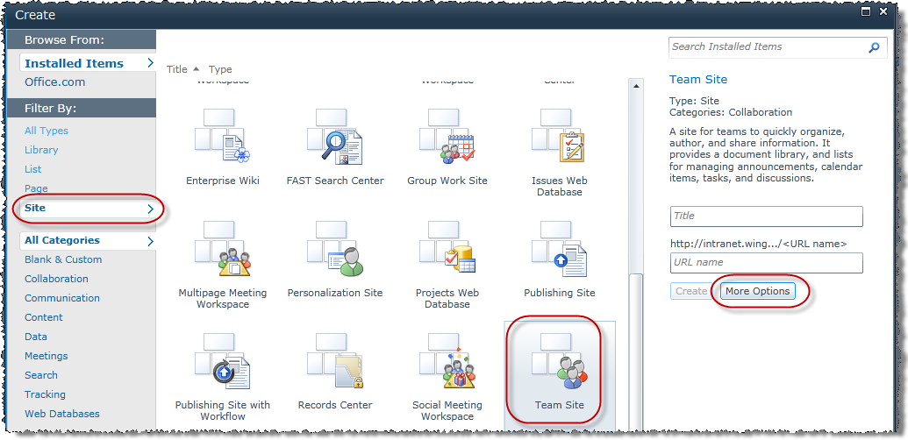

**Note**: Your experience may differ if you do not have the Silverlight runtime installed. This is a small & free download that you can install from <http://www.silverlight.net>. If you do not have Silverlight and cannot install it, the instructions are similar but not exact.

1. The left pane of the window should have changed from a listing of different template choice buttons to the options page for a new team site. Fill in the values according to the Wingtip team's agreement as follows:

**Title:** Scheduling

**Description:** Use this site to discuss, update and review manufacturing schedules.

**URL Name:** scheduling

**User Permissions:** Use same permissions as parent site

**Use the Top Navigation Bar from the parent site?:** Yes

1. Click **Create** to finish creating the new site. After a brief progress pop-up the home page of the new site will automatically open in the browser.
2. Navigate to the new **Scheduling** site's immediate parent site, Manufacturing, by clicking on the **Manufacturing** link in the Top Navigation Bar.
3. Alter the navigation settings on the Manufacturing site to show subsites in the Top Navigation Bar:
4. Click the **Site Actions** hyperlink in the upper left corner of the page.
5. Click the **Site Settings** link from the resulting **Site Actions** drop-down menu.
6. Click the **Navigation** link under the **Look and Feel** heading.
7. In the **Global Navigation** section, read the section description and leave the default radio button selection to **Display the navigation items below the current site**. Alter the setting by checking the **Show subsites** checkbox, enabling subsites to appear on the Top Navigation Bar of the site, then click **OK** to save your changes.

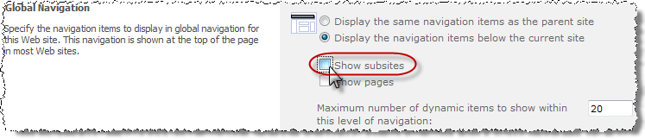

1. Return to the home page of the Manufacturing site via the breadcrumb trail and verify that the site's subsite appear as a link in the Top Navigation Bar:

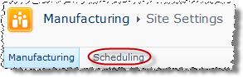

1. Navigate to the new **Scheduling** site via your preferred method and verify that the Top Navigation Bar links present on the parent Manufacturing site also appear on the Scheduling site.
2. Create a new subsite in the Wingtip Team Site site collection for your own use:
3. Navigate to the Wingtip Team Site site via your preferred method.
4. Click the **Site Actions** hyperlink in the upper left corner of the page.
5. Click the **New Site** link from the resulting Site Actions drop-down menu.
6. In the resulting **Create** dialog scroll down to the bottom of the template listing and click on the **Blank Site** button to select the template:

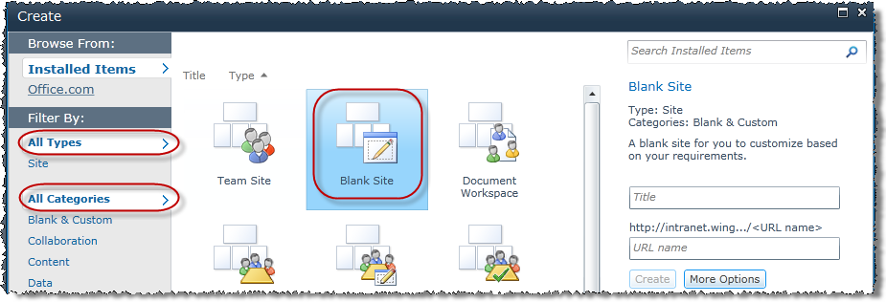

1. In the right pane of the window, the **Blank Site** template name and description should appear with the opportunity to create a new site with all default values by simply entering a title and URL value. Read the site description then click the **More Options** button to customize the site creation values.
2. The left pane of the window should have changed from a listing of different template choice buttons to the options page for a new blank site. Fill in the following values and click **Create** to create the site:

**Title:** {insert your first name here} Site

**Description:** The lab site for {insert your first and last name here}.

**URL Name:** {insert your first name here}

**User Permissions:** Use unique permissions

**Use the Top Navigation Bar from the parent site?** No

1. After the processing pop-up message concludes, use the **Set Up Groups for this Site** page to define the three required group objects.
2. Read the page description and note that you can choose to use existing SharePoint groups since you are creating a subsite into an existing site collection that will use unique permissions. Change the radio button selection in the **Visitors to this Site** section to **Create a new group** and accept the default group name. Leave the group void of any members for now.
3. Use your recently acquired skills to remove Rob from the **Members** group and add **Michael Sullivan** as the only member of the **Members** group.
4. Leave Rob as a member of the **Owners** group.

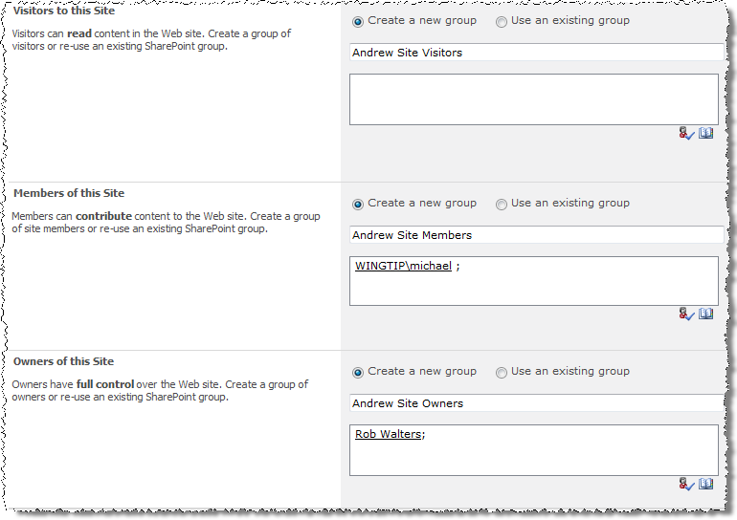Click

1. **OK** to finish creation of the new groups.

In this exercise you learned to create new sites.

## Exercise 2: Formatting Sites and Adding Features

In this exercise you will format a new site then activate and deactivate a Feature on it.

1. Log into your Wingtip Team Site site collection using the account **Ken Sanchez** which is the user designated as the site collection administrator.
2. Using Internet Explorer, browse to the URL of the SharePoint site collection you were provided to use when working on the hands on labs in this course.
3. When prompted to login, enter [[AD-DOMAIN]]\ken in the **User Name** field and click **OK**. Use the password specified in the *Hands-On Lab Overview* document provided in the student manual.
4. Apply a theme to your site:
5. Click the **Site Actions** hyperlink in the upper left corner of the page.
6. Click the **Site Settings** link from the resulting Site Actions drop-down menu.
7. Click the **Site theme** link under the **Look and Feel** heading.
8. In the **Select a Theme** section, click on a few of the themes that ship out of the box with SharePoint and notice the color pallet change to reflect the colors that are included in each theme.

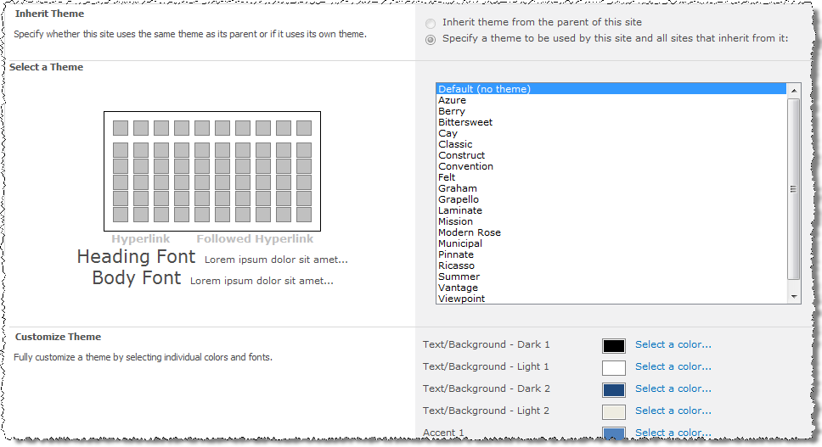

1. Once you've settled on a color combination you like, scroll to the bottom of the page and click **Apply** to apply the new colors to your site.
2. After a brief processing pop-up concludes, the new theme will immediately appear on your site.
3. Navigate back to the Wingtip Team Site using the **Navigate Up** button for the next step.
4. Explore changing the master page selection for an entire site collection:
5. Click the **Site Actions** hyperlink in the upper left corner of the page.
6. Click the **Site Settings** link from the resulting Site Actions drop-down menu.
7. Click the **Master page** link under the **Look and Feel** heading.
8. Read the page and notice that you can select an alternative **Site Master Page** and an alternative **System Master Page** from the corresponding drop-down menus. Do not change the current master page assignments:

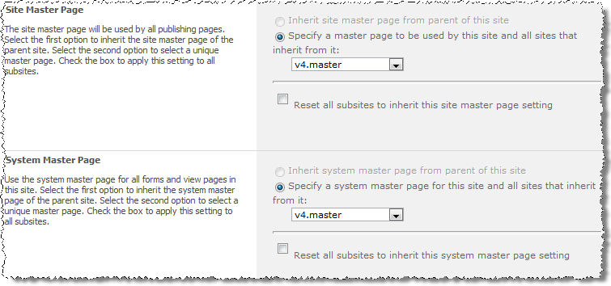

1. Notice that if you were to change the master page assignments there is a checkbox to reset all subsites below the current site (and their subsites and so on and so on down the hierarchy) so that those sites also use the new master page. Notice the checkbox is clear by default.

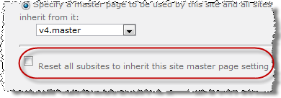

1. Scroll down the page to the **Alternate CSS URL** section. Notice that if a programmer or developer writes a custom Cascading Style Sheet (CSS) file you can refer to it with the 3rd radio button and all of the sites in this hierarchy will implement the custom stylization dictated by the file.

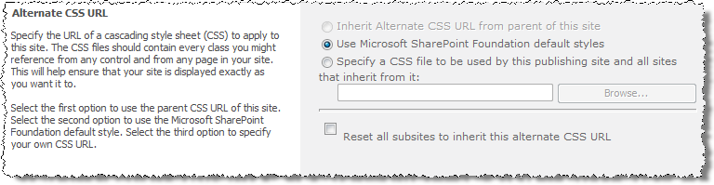

1. Click **Cancel** to exit the **Site Master Page Settings** page.
2. Navigate back to the site you created in the previous exercise. It should be under the Wingtip Team Site as a subsite and contain your name. You can find it using the **Site Actions » Site** Settings page and clicking the **Site hierarchy** link in the **Site Collection Administration** section.
3. Activate and deactivate a site scoped Feature:
4. Click the **All Site Content** link in the Quick Launch Bar and notice that there are no existing libraries or lists on the site. This is because you used the **Blank Site** template in the previous exercise to create your lab site:

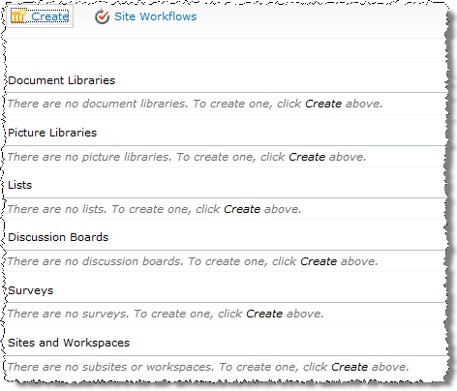

1. Click the **Site Actions** hyperlink in the upper left corner of the page.
2. Click the **Site Settings** link from the resulting Site Actions drop-down menu.
3. Click the **Manage site features** link under the **Site Actions** heading.
4. Examine the resulting page that lists all of the site-scoped Features that have been installed into SharePoint and reflects each one's activation status.
5. Scroll down to find the Feature named **SharePoint Server Publishing**. Read the feature's description to determine its functionality. From the **Status** column on the right document the current status of this site-scoped Feature.
6. Click the **Activate** button for the **SharePoint Server Publishing** Feature and wait for the page to refresh automatically in the browser.



1. Scroll down to the **SharePoint Server Publishing** Feature and verify that the status of the Feature is now **Active**.



1. Click the **Site Actions** hyperlink in the upper left corner of the page.
2. Click the **View All Site Content** link from the resulting Site Actions drop-down menu and notice that there are now libraries or lists on the site. These were added by the newly activated Feature.

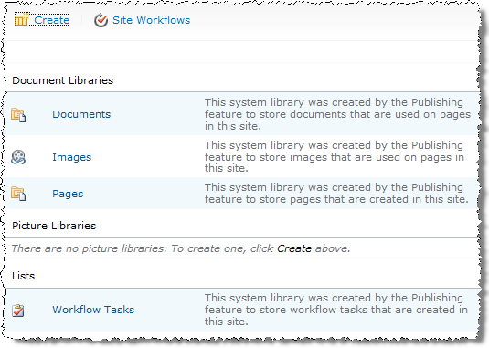

1. Click the **Site Actions** hyperlink in the upper left corner of the page.
2. Click the **Site Settings** link from the resulting Site Actions drop-down menu.
3. Click the **Manage site features** link under the **Site Actions** heading.
4. Scroll down to find the Feature named **SharePoint ServerPublishing**. Click the **Deactivate** button for the Feature.
5. In the resulting warning page, read the warning message then click the **Deactivate this feature** hyperlink and wait for the page to refresh automatically in the browser. Scroll down to the **SharePoint Server Publishing** Feature and verify that the status of the Feature is now blank (meaning inactive).
6. Click the **Site Actions** hyperlink in the upper left corner of the page.
7. Click the **View All Site Content** link from the resulting Site Actions drop-down menu and notice that the libraries or lists no longer exist. They were removed by the deactivation of the Feature.

In this exercise you practiced using Themes, Master Pages and Features.